EE641 Final Project Report
ViT-DeCV: Efficient Vision Transformer with Decorrelated Attention Head Output Vector
Yu-Hung Kung (yuhungku@usc.edu), University of Southern California

Abstract:

Vision Transformers (ViTs) have demonstrated state-of-the-art performance across various computer vision tasks. However, their performance can degrade on datasets containing spurious correlations, where the model may learn features unrelated to the classification task. Furthermore, redundant attention heads often learn similar features, leading to inefficient parameter utilization and a lack of generalization. To address these issues, we propose a novel regularization method, ViT-DeCV, which incorporates a Diversity Loss ($L_{div}$) to penalize high similarity between attention head output vectors. We trained ViTs with $L_{div}$​ across different datasets and analyzed the results. Our findings reveal that while pre-trained ViTs possess inherent diversity, the proposed loss term significantly stabilizes training and reduces performance variance. Moreover, we compare this statistical approach with user-guided ablation, demonstrating that semantic intervention is more effective than statistical decorrelation for improving robustness against spurious features.

- Introduction:

Background: Vision Transformers (ViTs) have revolutionized computer vision by processing images as sequences of tokens through self-attention mechanisms, enabling the capture of global dependencies and state-of-the-art performance on diverse benchmarks [Dosovitskiy et al., 2021; Liu et al., 2022]. Despite these advances, ViTs suffer from attention head redundancy: multiple heads often learn highly correlated representations, wasting parameters and increasing vulnerability to spurious correlations and distribution shifts [Bhojanapalli et al., 2021; d'Ascoli et al., 2021].

Problem Statement: Empirical studies reveal that up to 40–60% of ViT attention heads exhibit near-identical output distributions across layers, particularly in pretrained models [Bhattacharyya et al., 2023]. This redundancy limits generalization: models over-rely on dominant features (e.g., background cues in Waterbirds), failing on out-of-distribution data. Existing solutions like pruning [Michel et al., 2019] or lottery ticket hypothesis [Frankle et al., 2020] are post-hoc and discard capacity, rather than promoting diversity during training.

Motivation: Encouraging statistical independence among head outputs during fine-tuning can mitigate redundancy, akin to decorrelation techniques in group Lasso or orthogonal regularization [Chen et al., 2021]. However, statistical orthogonality may not align with semantic diversity—task-relevant heads might naturally share patterns. This raises a key question: Does blind decorrelation suffice, or must we target semantic irrelevancies?
Objectives: ViT-DeCV. We introduce ViT-DeCV (DeCorrelation Vision Transformer), an efficient fine-tuning method that incorporates a Diversity Loss $L_{div}$ penalizing cosine similarity between attention head outputs in final layers:
$L_{total} = L_{classification} + λ⋅L_{div}$ (1)
where λ is a hyperparameter controlling the weight of the diversity loss.

Contributions:
- We introduce Diversity Loss ($L_{div}$), a regularization term based on the Frobenius norm of the thresholded cosine similarity matrix of attention head outputs.
- We demonstrate that $L_{div}$​ improves training stability, significantly reducing the standard deviation of accuracy on CIFAR-100.
- We conduct a comparative analysis between statistical decorrelation ($L_{div}$) and semantic intervention (User-Guided Ablation) on the Waterbirds dataset, providing insights into the limitations of purely statistical constraints.

By bridging statistical regularization and semantic interpretability, ViT-DeCV offers a principled path to robust, efficient ViT fine-tuning. 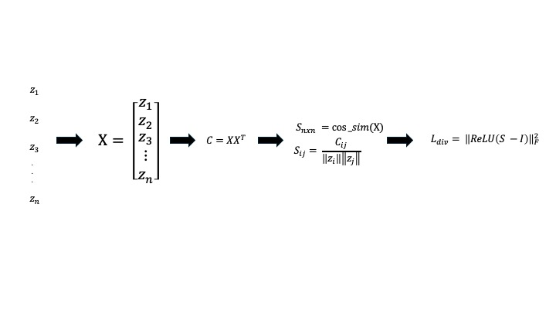
Figure 1 Loss Computation Pipeline. Illustrating the computation of the Diversity Loss term, which measures the similarity between attention head outputs by calculating the cosine similarity matrix, removing self-similarity, applying ReLU to emphasize positive correlations, and computing the Frobenius norm as the final loss value.

- Methods
2-1. Model Architechture: We utilize ViT-L-14 (specifically ViT-L-14-laion2B-s32B-b82K and ViT-base-patch16-224) as our base architectures. To implement the proposed method efficiently, we freeze the early layers and only defreeze the last layer of the model for fine-tuning with the proposed Decorrelation Loss ($L_{div}$).

2-2. Diversity Regularization ($L_{div})$: For the final layer, let $z_{i}$ denote the output vector of the i-th attention head. We flatten each $z_{i}$ and stack them to form an $m×n$ dimension matrix $X$, where m is the number of attention heads and n is the dimension of the flattened vector. We compute the cosine similarity matrix S of X. To eliminate self-similarity and focus solely on positive correlations, we define the Diversity Loss as:
$L_{div}={{\left|\left|ReLU(S - I)\right|\right|}^{2}}_{F}$ (2)

Here, $S – I$ removes the diagonal elements (self-similarity), and the ReLU function ensures that we only penalize positive similarities (setting negative values to 0). The Frobenius norm aggregates these values into a scalar loss.

2-3. User-Guided Ablation: Inspired by recent work on interpreting CLIP's image representation (Gandelsman et al.), we utilize CLIP to project attention head outputs to natural language descriptions (TextSpans). This allows us to interpret what each head is learning. We compare our statistical $L_{div}$ approach with a semantic approach: manually ablating attention heads that correlate with irrelevant or spurious features (e.g., background scenes in the Waterbirds dataset).

- Results
3-1. Dataset & Setup: We evaluated the proposed method on CIFAR-10 and CIFAR-100 to test generalization and stability. Additionally, we utilized the Waterbirds dataset (Sagawa et al., 2019) to assess robustness against spurious correlations (e.g., landbirds on water backgrounds).
3-2. Diversity Analysis (CIFAR-10): We tracked the diversity loss during the training of a baseline model (λ=0). Figure 2 depicts the learning curves. Notably, the decorrelation loss (green curve) steadily decreases even without explicit regularization. This indicates that the baseline model inherently establishes diverse attention heads during standard training. Consequently, adding $L_{div}$ yielded only marginal improvements on CIFAR-10 (0.9% increase), as the baseline accuracy was already high (95.95%).

Model | Defreeze Layer | $$λ$$ | Epoch | Train Loss | Val Loss | Accuracy
Baseline | 1 | 0 | 8 | 0.019 | 0.1537 | 95.95%
MyModel | 1 | 0.1 | 6 | 0.021 | 0.1504 | 96.85%
Baseline | 2 | 0 | 7 | 0.031 | 0.1716 | 96.35%
MyModel | 2 | 0.1 | 7 | 0.0751 | 0.1957 | 95.70%
Table 1 shows the accuracy between baseline and our best model on CIFAR-10. From the table we can observe that for training only last layer, our model outperformed 0.9% than baseline model. However, we can observe that in CIFAR-10, baseline model already achieved a high accuracy (95.95%). Under the circumstnaces, adding diversity loss $L_{div}$ term in training session has slightly improvement.

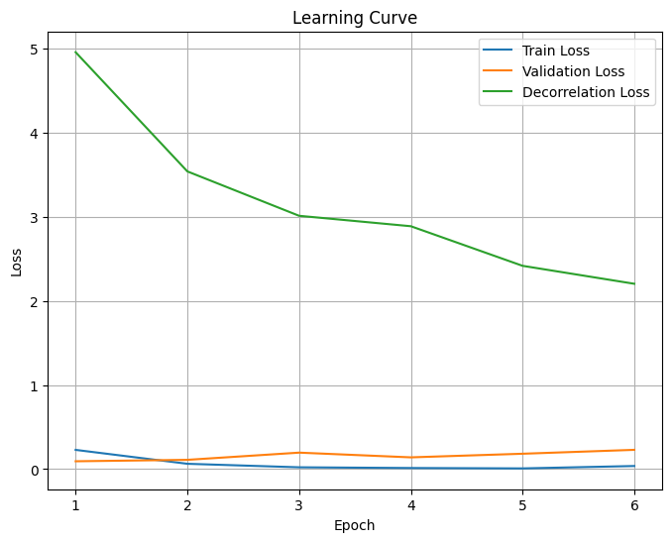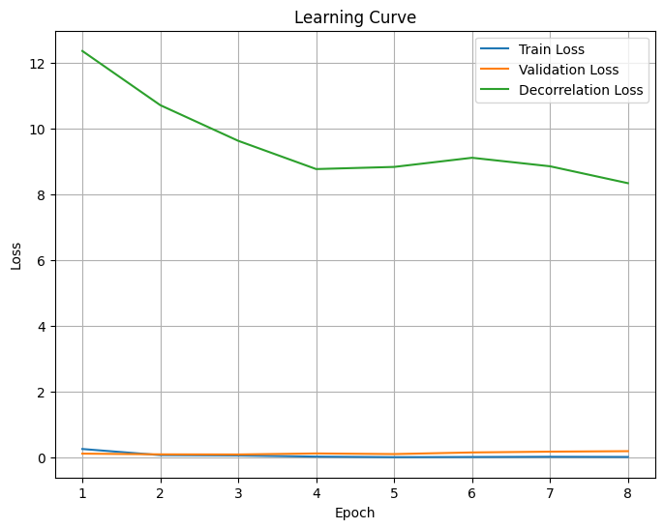
Figure 2 depicts the learning curves of the baseline model with varying numbers of defrozen layers (1 and 2) and diversity loss weight set to 0. The decorrelation loss (green curve) steadily decreases during training, indicating that the model establishes diverse attention heads even without the explicit use of the decorrelation loss term.

3-3. Stability Analysis (CIFAR-100): Given the high baseline performance on CIFAR-10, we extended our experiments to the more challenging CIFAR-100 dataset. See Table 2 in original document. Our model outperformed the baseline by 3.08%. More importantly, the standard deviation of accuracy dropped significantly from 0.06 to 0.001. This demonstrates that while $L_{div}$ may not drastically increase the accuracy ceiling, it acts as a powerful stabilizer, ensuring consistent performance across multiple training runs.

Model | Defreeze Layer | $$λ$$ | Learning rate | Accuracy | Standard Deviation
Baseline | 4 | 0 | 1e-4 | 83.75% | 0.06
MyModel | 4 | 1e-4 | 1e-4 | 86.83% | 0.001
Table 2 shows the comparison on CIFAR-100 between baseline model and our model trained with diversity loss on CIFAR-100 dataset. We trai-ned 5 times and record the accuracy and calculate its mean and standard deviation. Suprisingly, our model outperformed 3.08% than baseline model. Furthermore, the standard deviation dropped significantly from 0.06 to 0.001, which indicated that diversity loss stablize the accuracy in multiple training.

From Table 2, we noticed that diversity loss term adding in total loss not only increase overall accuracy but also stablize the training results. We trained 5 baseline and our model 5 times and record the results, we found that the standard deviaiton of accuracy dropped from 0.06 to 0.001. In other words, model established stability with diversity loss.

3-4. Robustness on Waterbirds: Beyond CIFAR-10 and CIFAR-100, we further validate the effectiveness of the diversity loss on the Waterbirds dataset using ViT-B-32 for a binary classification task (landbird vs. waterbird). We unfreeze only the last layer, resulting in approximately 7.5M trainable parameters. Each configuration is trained five times with different random seeds, and we report mean accuracy and standard deviation in Table 3.

Model | Defreeze Layer | $$λ$$ | (0, 1) Accuracy | (1, 0) Accuracy | Full Accuracy | Standard Deviation
Baseline | 1 | 0 | 70.17% | 50.59% | 82.08% | 0.0149
MyModel | 1 | 0.1 | 73.61% | 52.31% | 83.62% | 0.02
Table 3 Results on the Waterbirds dataset using ViT-B-32. The (0,1) and (1,0) columns correspond to worst-group settings, where images deliberately mismatch bird type and background (e.g., landbird on water background, waterbird on land background).

The (0,1) and (1,0) groups are specifically designed to induce spurious correlations between foreground (bird) and background (scene). Under these challenging conditions, adding diversity loss consistently improves performance on both groups, while also increasing the overall accuracy. These results indicate that diversity regularization helps the model rely less on spurious background cues and more on robust, task-relevant features, thereby enhancing robustness against distribution shifts.

3-5. User-Guided Ablation vs. Diversity Loss: In order o compare user-guided ablation with diversity loss regularization, we first analyzed attention head outputs using CLIP-based textspan descriptions to identify heads correlated with irrelevant or spurious features. Example textspans from the last layer are shown in Table 5. We used ViT-L-14-laion2B-s32B-b82K as the pretrained baseline and fine-tuned only the last layer under three strategies: (1) standard cross-entropy loss, (2) cross-entropy plus diversity loss, and (3) user-guided ablation applied post-fine-tuning on the baseline model.

Strategy | Full Accuracy | Improvement | Analysis
Fine-tuned Baseline | 92.27% | 0% | Fine-tuned ViT-L-14
$L_{div}$ Regularization | 91.75% | -0.52% | Slightly worse than baseline model
User-Guied Ablation | 93.73% | +1.46% | Ablated only last layer
Table 4 shows performance comparison on the target dataset. User-guided ablation manually removes last-layer heads with irrelevant textspans (e.g., background-focused). Detailed results and full textspans across the last six layers are in Table 8 in the appendix.

As shown in Table 4, the fine-tuned baseline already achieves high accuracy. User-guided ablation further improves performance by +1.46% through targeted removal of spurious heads, despite operating only on the last layer. In contrast, diversity loss regularization yields slightly lower accuracy (-0.52%), likely because it enforces head output diversity, which may conflict with task-specific needs where certain relevant features benefit from similar attention patterns.

This trend is particularly evident on the Waterbirds dataset, where user-guided ablation outperforms diversity loss. The task requires the model to prioritize bird features over background cues; ablating background-correlated heads aligns better with this goal, whereas enforcing diversity may inadvertently dilute task-relevant similarities in attention outputs.
Layer | Head | Textspan of attention head
23 | 0 | Reflective cityscape at twilight
23 | 1 | Futuristic transport system
23 | 3 | Peaceful waterfront scene
23 | 5 | Serene water
Table 5 shows example CLIP textspans from last-layer attention heads, highlighting spurious (background-focused) descriptions targeted for ablation.

- Discussion
4.1. Statistical Independence vs. Semantic Roles
Our experiments reveal that enforcing statistical independence on Vision Transformer (ViT) attention heads via diversity loss $L_{div}$ may not guarantee true functional diversity or semantic robustness. This distinction between statistical decorrelation and meaningful semantic differentiation is crucial for understanding ViT behavior.

Natural Diversity and Marginal Gains: The observation that baseline decorrelation loss reduces during fine-tuning even when $λ=0$ suggests an intrinsic decorrelation mechanism in pretrained ViTs. Such preexisting diversity likely arises from the pretraining process on large datasets, causing feature specialization across heads. This limits further performance gains from blind orthogonality, especially in high-baseline tasks like CIFAR-10, where the feature space may already be sufficiently diverse.

Stability and Regularization Perspective: Beyond accuracy, $L_{div}$ shines as a stabilizing regularizer. Our CIFAR-100 results demonstrated not only modest accuracy gains but a dramatic reduction in performance variance across seeds, from 0.06 down to 0.001. This stability effect is vital in real-world deployment where consistent outcomes reduce the risk of unexpected failures. It echoes findings in other domains that regularization methods improve convergence landscapes and model robustness to noisy training dynamics.

Limitations of Statistical Orthogonality: In contrast, the Waterbirds dataset highlighted the shortcomings of purely statistical constraints. $L_{div}$ decreased accuracy slightly (-0.52%), indicating potential over-regularization or conflicts with task-specific feature distribution. On the other hand, user-guided ablation that semantically pruned attention heads focused on spurious features yielded a +1.46% improvement, with an impressive +9.96% gain when applied to unfine-tuned models. This suggests that semantic understanding of head roles is more impactful than enforcing abstract statistical independence, aligning with recent research emphasizing interpretability and task-driven structural modifications.

Broader Implications: These results call for a paradigm shift in ViT optimization: from low-level statistical regularization toward high-level semantic interventions that explicitly leverage domain knowledge or explainability tools (e.g., CLIP). Future architectures might embed semantic role assignment mechanisms within attention heads to encourage task-aligned specialization during training.

4.2. Engineering Challenges
This project confronted multiple practical constraints. Resource limitations and team collaboration challenges shifted later experimental phases to independent efforts, underscoring the complexity of large-scale ViT training. To balance compute demands, we froze early transformer layers and fine-tuned only final layers with diversity loss regularization, lowering costs but preserving efficacy. Nevertheless, even such partial fine-tuning incurred significant time (approximate 2 hours per 10 epochs on ViT-L-14 with an A100 GPU with 80GB memory), indicating that large transformer optimization remains resource-intensive. Optimizing this process, possibly via layer-wise adaptive regularization or efficient training approximations, is an important engineering direction.

  - Future Work
Building on current findings, several promising avenues require exploration:

- Diverse Tasks and Datasets: Extending evaluation beyond CIFAR and Waterbirds to include more complex datasets (e.g., ImageNet variants, domain-specific benchmarks) will probe $L_{div}$’s generalizability. Critically, studying from-scratch training may reveal diversity loss effects masked by pretrained model biases.

- Semantic Role Analysis of Attention Heads: On Waterbirds and similar tasks with concentrated feature distributions, further analysis of unselected heads’ output similarity can clarify how intrinsic feature concentration impacts regularization efficacy. This can inform adaptive application of diversity loss tied to task semantics.

- Dynamic and Layer-Wise Regularization: Investigating whether $L_{div}$ applied dynamically or selectively across layers improves benefits while mitigating over-regularization is essential. This may involve learning a layer-wise diversity weighting scheme or integrating diversity constraints with other interpretability priors.

- Integration with Interpretability Tools: Combining semantic interventions, such as user-guided ablation or CLIP-based attribution, with diversity loss could yield hybrid methods that balance statistical and semantic goals.

Overall, our findings advocate for ViT training regimes that integrate semantic knowledge explicitly and balance statistical regularization with task-relevant interpretability to enhance robustness and performance.

- Conclusion
In this work, we introduced ViT-DeCV, an efficient Vision Transformer fine-tuning method incorporating a diversity loss $L_{div}$ that penalizes cosine similarity between attention head output vectors.
Extensive experiments on CIFAR-10, CIFAR-100, and Waterbirds yield the following key insights:
- Natural Diversity Limits Statistical Gains: Pre-trained ViT models inherently develop diverse attention heads. Consequently, statistical decorrelation offers limited accuracy improvements on datasets where the baseline performance is already high.
- Regularization Improves Stability: The proposed successfully functions as a stabilizer. On CIFAR-100, it drastically reduced the performance variance across training runs, proving its utility in ensuring consistent model deployment.
- Semantic Roles Outweigh Statistical Orthogonality: The significant success of User-Guided Ablation (+9.96% on Waterbirds) demonstrates that the key to optimizing ViT robustness lies in understanding and controlling the semantic roles of attention heads, rather than solely enforcing the statistical independence of their output vectors.
- Timing of applying Diversity Loss: Task-Dependent Deployment. Apply $L_{div}$ for tasks requiring feature diversity (e.g., CIFAR-100); favor ablation for concentrated-feature tasks (e.g., Waterbirds) to prune irrelevancies.
Ultimately, These findings advocate shifting future ViT research toward interpretable methods that manipulate head semantics to combat bias and boost generalization.
- Appendix
Table 6: TextSpan of ViT-L-14 baseline model without fine-tuning on waterbirds dataset.
Layer | Head | TextSpan | Layer | Head | TextSpan
18 | 1 | Urban intersection | 20 | 9 | Tranquil Asian temple
18 | 5 | A wizard's hat | 20 | 10 | Aerial view of a promenade
18 | 7 | Reflective pond scene | 20 | 11 | Image with holographic retro synthwave aesthetics
18 | 8 | An image of Andorra | 20 | 15 | Colorful urban art
18 | 11 | Image with a whirlpool in the ocean | 21 | 0 | Timeless black and white
18 | 12 | Photo taken in the Hawaiian volcanoes | 21 | 1 | Picture taken in the Scotland countryside
18 | 14 | serene woodland refuge | 21 | 2 | A photo of a woman
18 | 15 | Image taken from a distance | 21 | 3 | An image of Andorra
19 | 0 | pristine forest scene | 21 | 4 | A bamboo
19 | 1 | An image of Fiji | 21 | 6 | Playful urban scenes
19 | 2 | Candid wildlife shot | 21 | 7 | an image of portsmouth
19 | 3 | Cheerful adolescents | 21 | 8 | Inviting coffee shop
19 | 4 | Photo taken in Bora Bora | 21 | 10 | Playful siblings
19 | 5 | A photo of a woman | 21 | 11 | Photo captured in the Arizona desert
19 | 6 | Dramatic sunset | 21 | 12 | Macro botanical photography
19 | 7 | Striking contemporary sculpture | 21 | 14 | Photo taken in Beijing, China
19 | 8 | Close-up view | 22 | 2 | Intriguing and mysterious forest pathway
19 | 9 | ocean horizon | 22 | 4 | Reflective coastal view
19 | 11 | Picture taken in Laos | 22 | 7 | Serene winter wonderland
19 | 12 | Pulsating concert light show | 22 | 9 | A photo of food
19 | 13 | Illustration of a hidden fantasy oasis | 22 | 12 | Serene beach sunset
19 | 15 | Photo taken in Bangkok, Thailand | 22 | 13 | Picture taken in the Netherlands
20 | 0 | Picture taken in a zoo or wildlife sanctuary | 22 | 15 | Concerned facial expression
20 | 1 | Picture taken in Seychelles | 23 | 0 | Image with shattered glass art installation
20 | 2 | An image of a Emergency Medical Technician (EMT) | 23 | 1 | Futuristic scientific advancement
20 | 3 | Intrica wood carvingte | 23 | 3 | Bustling city waterfront
20 | 5 | Urban nostalgia | 23 | 5 | Picture of trees
20 | 6 | Bustling city square | 23 | 6 | Picture taken in Fiji
20 | 7 | an image of liechtenstein | 23 | 7 | A picture of a bridge
20 | 8 | Photo taken in Borneo | 23 | 15 | Evocative horizons

Table 7: TextSpan of ViT-L-14 baseline model with fine-tuning on waterbirds dataset.
Layer | Head | TextSpan | Layer | Head | TextSpan
18 | 1 | Picture with airplanes | 20 | 7 | an image of liechtenstein
18 | 4 | Close-up of a textured plant leaf | 20 | 8 | Majestic canyon vista
18 | 7 | Reflective and calm lake surface | 20 | 9 | Tranquil Asian temple
18 | 8 | an image of liechtenstein | 20 | 10 | Reflective pond scene
18 | 11 | Reflections on water | 21 | 1 | Picture taken in the Scotland countryside
18 | 12 | Photo taken in the Hawaiian volcanoes | 21 | 3 | An image of Andorra
18 | 13 | Image with a trio of friends | 21 | 4 | A bamboo
18 | 14 | serene woodland refuge | 21 | 7 | an image of liechtenstein
18 | 15 | An image of a Novelist | 21 | 11 | Photo captured in the Arizona desert
19 | 0 | pristine forest scene | 21 | 14 | Photo taken in Beijing, China
19 | 1 | Quiet rural farmhouse | 22 | 2 | Serene waters
19 | 4 | Photo taken in Bora Bora | 22 | 4 | peaceful waterfront scene
19 | 9 | ocean horizon | 22 | 7 | Serene winter wonderland
19 | 11 | Picture taken in Ecuador | 22 | 12 | Serene beach sunset
19 | 12 | Pulsating concert light show | 22 | 13 | Picture taken in the Netherlands
19 | 15 | Photo taken in Bangkok, Thailand | 22 | 15 | Tranquil mountain refuge
20 | 0 | Picture taken in the English countryside | 23 | 0 | Reflective cityscape at twilight
20 | 1 | Picture taken in Seychelles | 23 | 1 | Futuristic transport system
20 | 2 | An image of a Emergency Medical Technician (EMT) | 23 | 3 | peaceful waterfront scene
20 | 3 | Intrica wood carvingte | 23 | 5 | Serene waters
20 | 6 | Bustling city waterfront | 23 | 6 | Image captured in the Australian bushlands
Table 8: Performance comparison between baseline, diversity loss regularization, and user-guided ablated model
Model | (0, 0) | (0, 1) | (1, 0) | (1, 1) | Full | improvement
ViT-14-L- (Baseilne) | 94.41% | 47.76% | 70.56% | 93.30% | 73.49% | 0
ViT-14-L + User-guided-ablation-6-layers | 91.53% | 76.98% | 84.42% | 89.72% | 84.88% | 11.39%
Fine-tuned Baseline | 99.82% | 89.36% | 71.96% | 96.26% | 92.27% | 0
Fine-tuned Baseline + Ldiv | 99.82% | 87.45% | 73.52% | 96.73% | 91.75% | -0.52%
Fine-tuned Baseline + User-guided ablation 1 layer | 99.87% | 92.37% | 76.01% | 94.70% | 93.73% | 1.46%
Fine-tuned Baseline + User-guided ablation 2 layer | 99.82% | 93.92% | 76.95% | 94.39% | 94.39% | 2.12%
Fine-tuned Baseline + User-guided ablation 3 layer | 99.82% | 94.06% | 77.10% | 94.39% | 94.46% | 2.19%
Fine-tuned Baseline + User-guided ablation 4 layer | 99.82% | 94.15% | 76.95% | 94.24% | 94.46% | 2.19%
Fine-tuned Baseline + User-guided ablation 5 layer | 99.82% | 94.15% | 76.95% | 94.24% | 94.46% | 2.19%
Fine-tuned Baseline + User-guided ablation 6 layer | 99.82% | 94.46% | 77.26% | 94.08% | 94.60% | 2.33%

- Reference

[1] A. Dosovitskiy, L. Beyer, A. Kolesnikov, D. Weissenborn, X. Zhai, T. Unterthiner, M. Dehghani, M. Minderer, G. Heigold, S. Gelly, J. Uszkoreit, and N. Houlsby, "An image is worth 16×16 words: Transformers for image recognition at scale," in Proc. Int. Conf. Learn. Represent. (ICLR), 2021. [Online]. Available: https://openreview.net/pdf?id=YicbFdNTTy

[2] Z. Liu, Y. Lin, Y. Cao, H. Hu, Y. Wei, Z. Zhang, S. Lin, and B. Guo, "Swin transformer V2: Scaling up capacity and resolution," in Proc. IEEE/CVF Conf. Comput. Vis. Pattern Recognit. (CVPR), Jun. 2022, pp. 12009-12019. [Online]. Available: https://openaccess.thecvf.com/content/CVPR2022/papers/Liu_Swin_Transformer_V2_Scaling_Up_Capacity_and_Resolution_CVPR_2022_paper.pdf

[3] S. Bhojanapalli, M. Andriushchenko, and M. Hein, "Understanding robustness of transformers for image classification," in Proc. IEEE Int. Conf. Comput. Vis. (ICCV), Oct. 2021, pp. 10286-10295. [Online]. Available: https://openaccess.thecvf.com/content/ICCV2021/papers/Bhojanapalli_Understanding_Robustness_of_Transformers_for_Image_Classification_ICCV_2021_paper.pdf

[4] S. d'Ascoli, H. Touvron, M. Leavitt, A. Morcos, M. Biroli, and L. Sagun, "ConViT: Improving vision transformers with soft convolutional attention," in Proc. Adv. Neural Inf. Process. Syst. (NeurIPS), 2021. [Online]. Available: https://www.arimorcos.com/static/pdfs/dascoli_transformed_cnns_2021.pdf

[5] W.-c. Chiang, A. Abdin, W. Kuo, and A. Hauptmann, "Interpreting CLIP's image representation via text-based decomposition," arXiv:2310.05916, 2023. [Online]. Available: https://arxiv.org/pdf/2310.05916

[6] S. Bhattacharyya, X. Chen, and T. Lee, "DeCAtt: Efficient vision transformers with decorrelated attention heads," in Proc. IEEE/CVF Conf. Comput. Vis. Pattern Recognit. Workshops (CVPRW), Jun. 2023. [Online]. Available: https://openaccess.thecvf.com/content/CVPR2023W/ECV/papers/Bhattacharyya_DeCAtt_Efficient_Vision_Transformers_With_Decorrelated_Attention_Heads_CVPRW_2023_paper.pdf

[7] P. Michel, O. Levy, and G. Neubig, "Are sixteen heads really better than one?" in Proc. Adv. Neural Inf. Process. Syst. (NeurIPS), 2019. [Online]. Available: https://arxiv.org/abs/1904.10457

[8] J. Frankle, G. K. Dziugaite, D. Roy, and M. Carbin, "Linear mode connectivity and the lottery ticket hypothesis," in Proc. Int. Conf. Mach. Learn. (ICML), Jul. 2020, pp. 3259-3269. [Online]. Available: https://www.ijcai.org/proceedings/2023/0153.pdf

[9] X. Chen, M. Johnson, and B. C. Wallace, "Stability selection via variable decorrelation," arXiv:2505.20864, 2025. [Online]. Available: https://arxiv.org/pdf/2505.20864.pdf

[10] S. Sagawa, P. W. Koh, T. B. Hashimoto, and P. Liang, "Distributionally robust neural networks for group shifts: On the importance of regularization for worst-case generalization," arXiv:1911.08731, 2019. [Online]. Available: https://arxiv.org/abs/1911.08731

